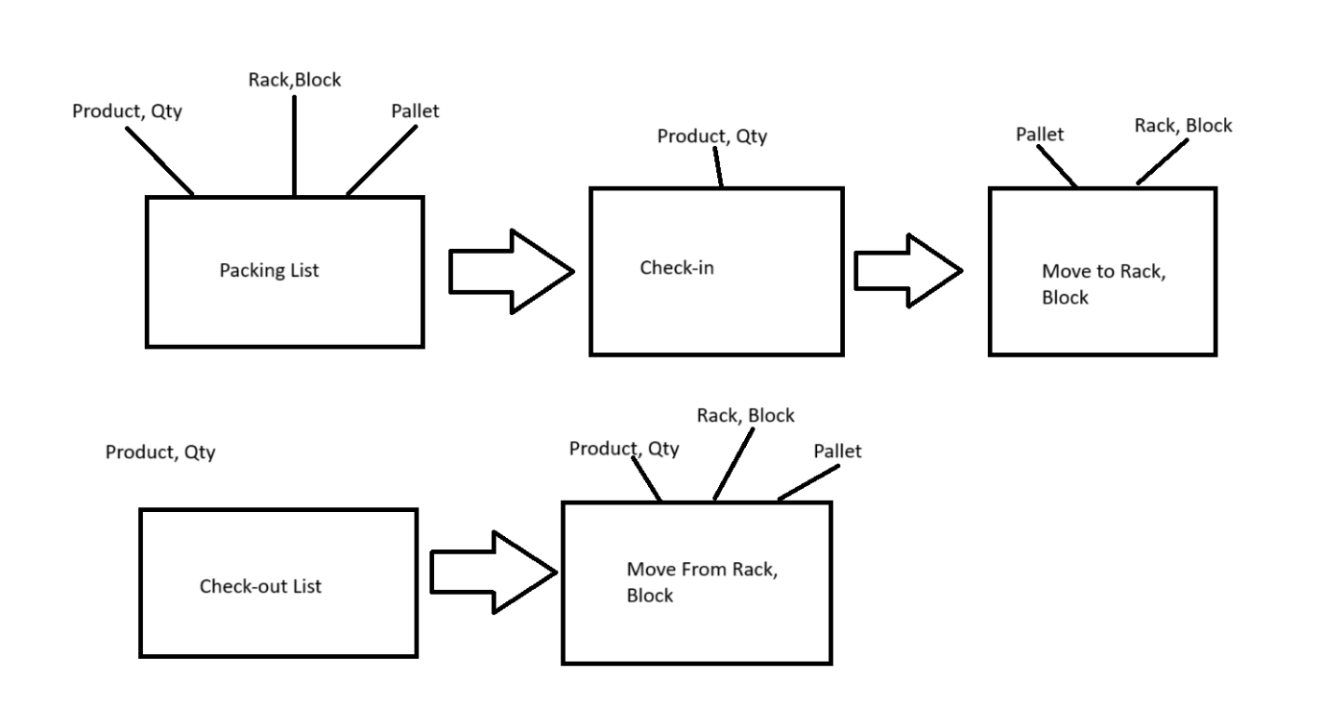

Racks Management

* Racks Management
  + Location
  + Racks
    - Rows
    - Columns
    - Blocks
      * area (w x d)
      * height
      * support weight
* Pallets
  + Size (w x d)
* Store Management
  + Product Check-in
    - MFG Lot Travelling, Material, Spare part and Tool
  + Pallet Check-in
    - Product Lot ID
    - Storage Size, (weight, height, support weight)
    - Upper of (Unoccupied Block Area/Pallet)
  + Pallet Check-out
    - Lot
  + Moving Pallet
    - Pallet-in
    - Pallet-out
  + Available Block Area
    - Unoccupied Block Area with weight
    - Available Paller Area with weight